**CONNECT COPY INSTANCE**

**Cargo AWS Connect Contact**

**Centre Set-Up**

For

**Singapore Airlines (SIA)**

**Installation guide links**

1. Link for GitHub: <https://github.com/aws-samples/amazon-connect-copy>
2. Installation Guide for Aws Cli: <https://docs.aws.amazon.com/cli/latest/userguide/getting-started-install.html>
3. Installation Link for Jq: <https://stedolan.github.io/jq/download/>

**Command line and output result text file.**

Click on this icon below.



1. **GitHub Cloning**

First step is to click on this link: <https://github.com/aws-samples/amazon-connect-copy>

After clicking this link, It takes to this page below.

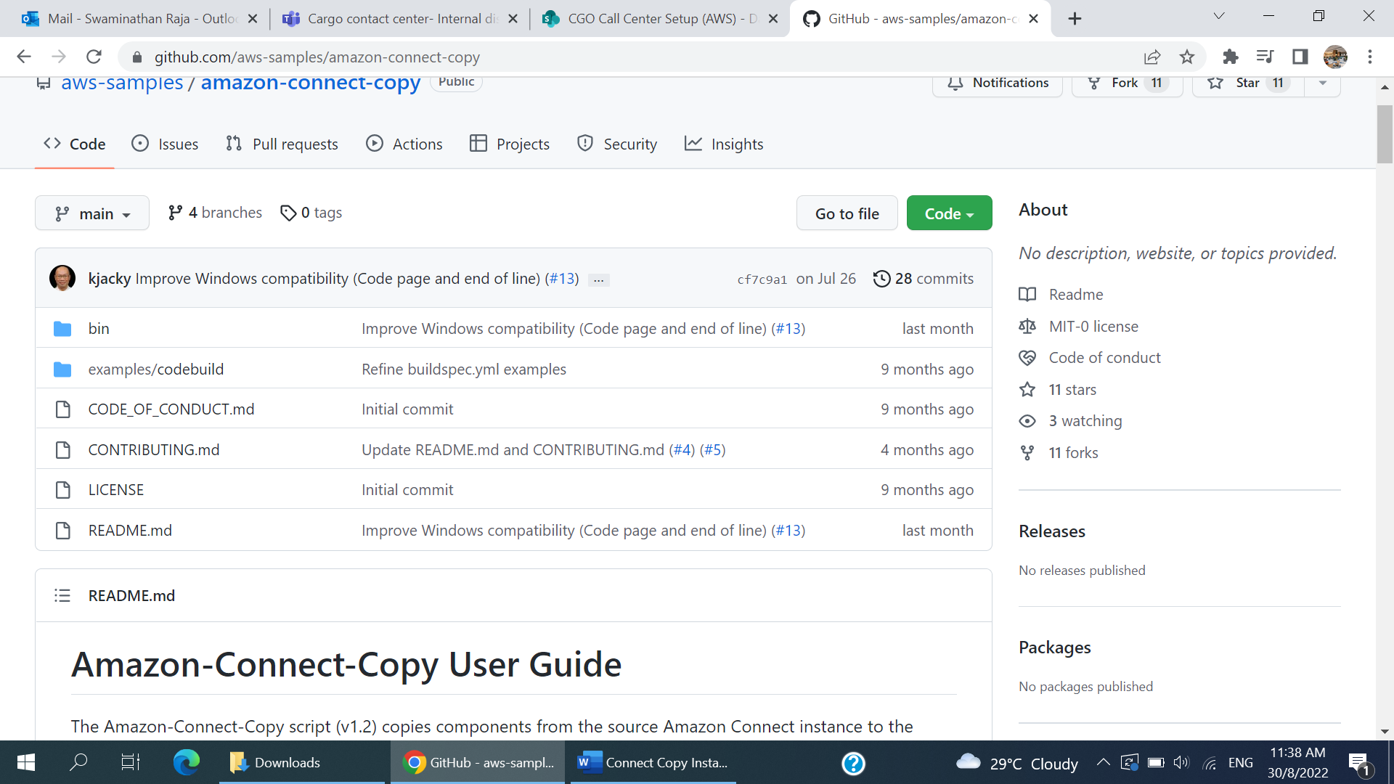

After Getting to this page, Click on the Green button which shows Code



Once Clicked on the Code button, Copy the link.

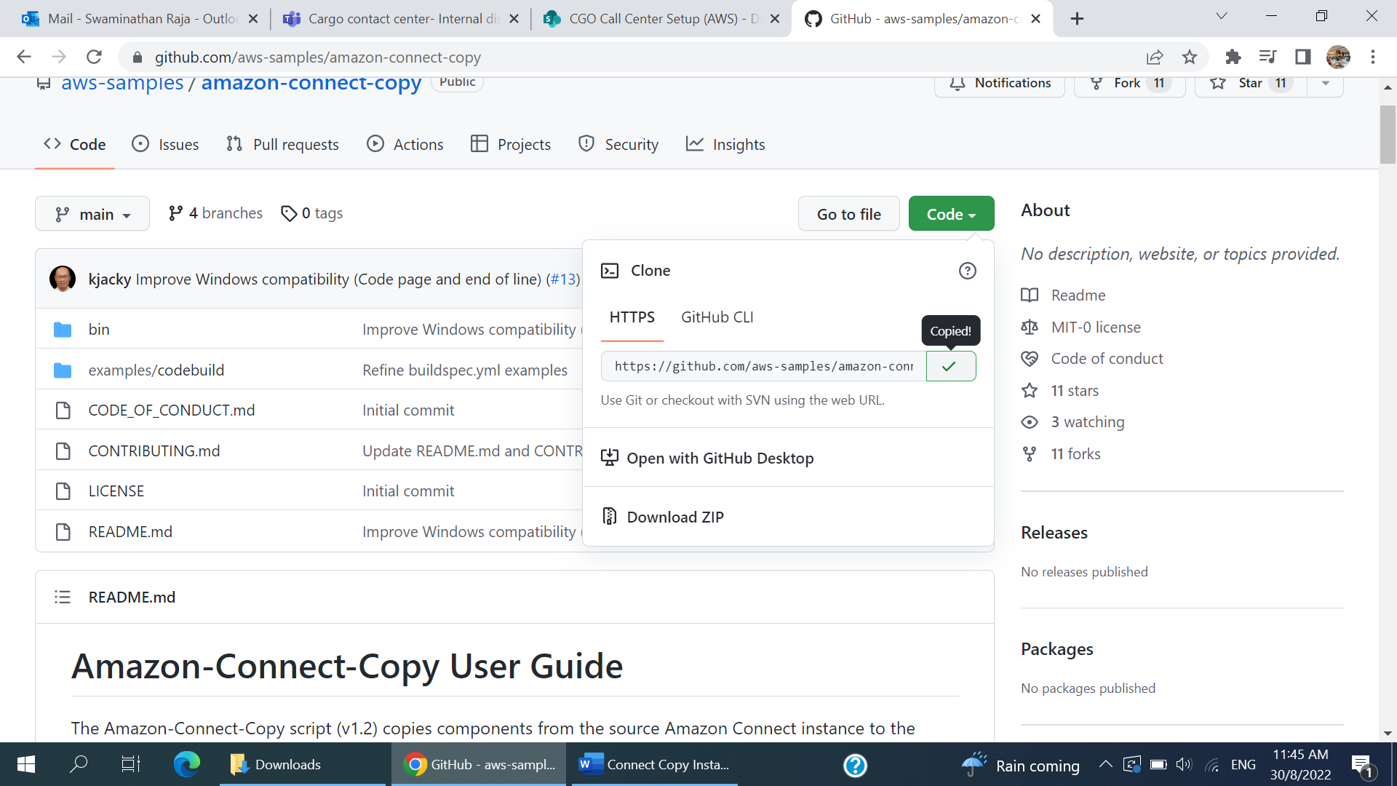



Once the Link has been copied, go to Visual studio and open the terminal.

Use cd command to change directory to Cargo folder.

Type in git clone along with the copied link as follows :

**~ $ git clone** [**https://github.com/aws-samples/amazon-connect-copy.git**](https://github.com/aws-samples/amazon-connect-copy.git)

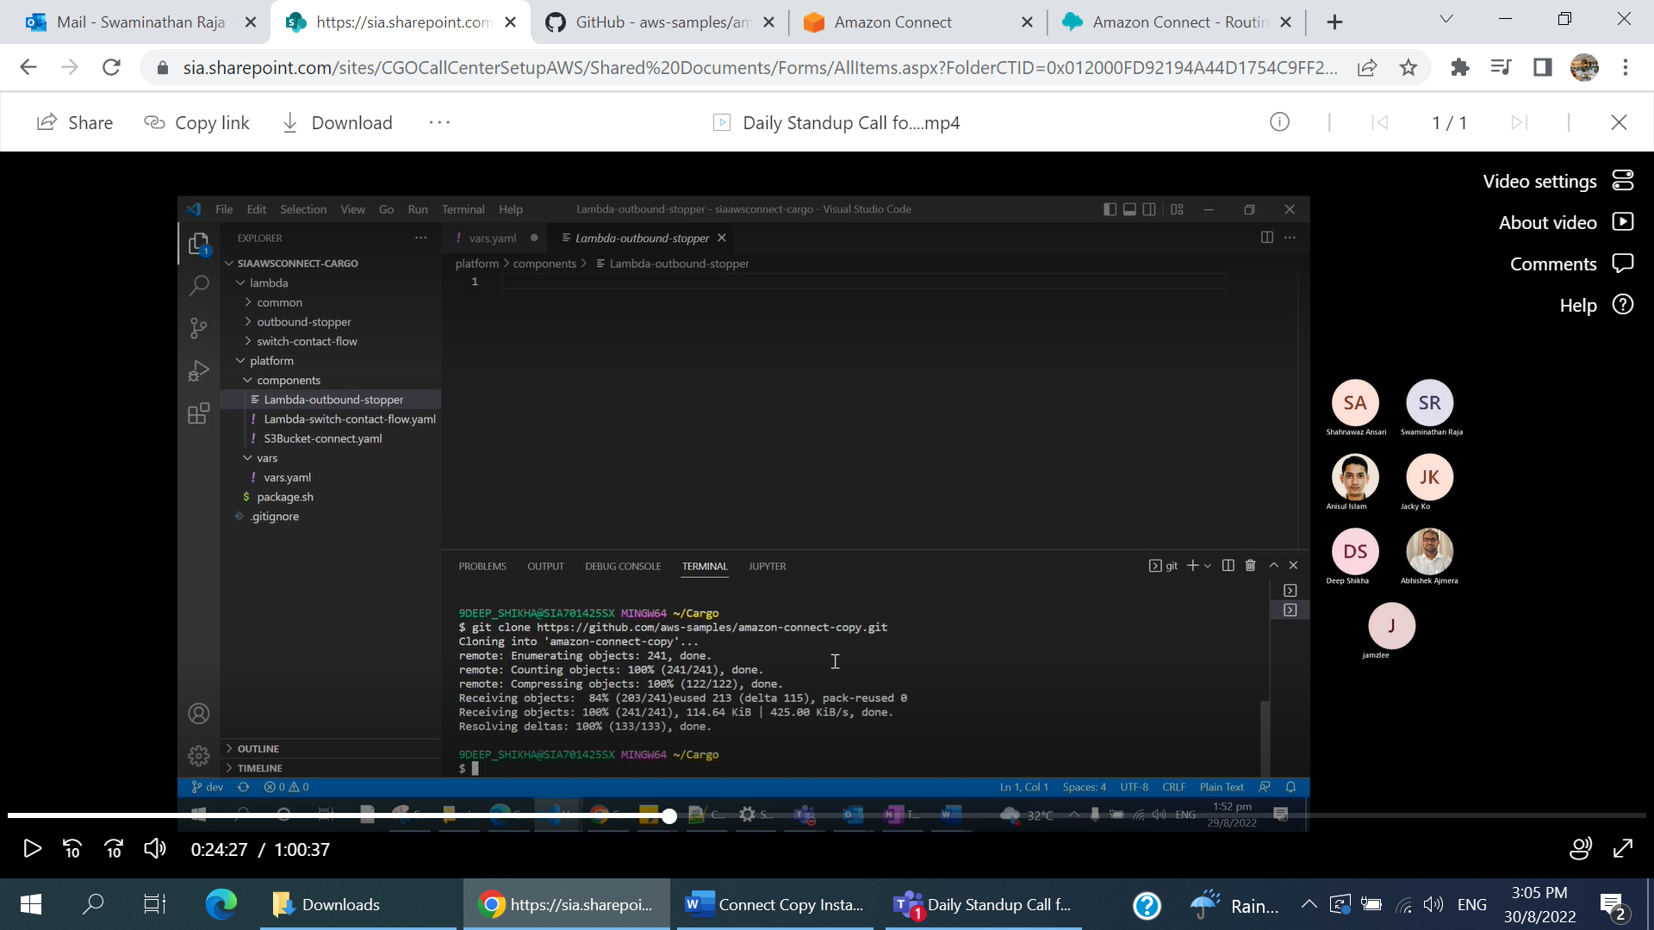

After this step, change directory to amazon-connect-copy

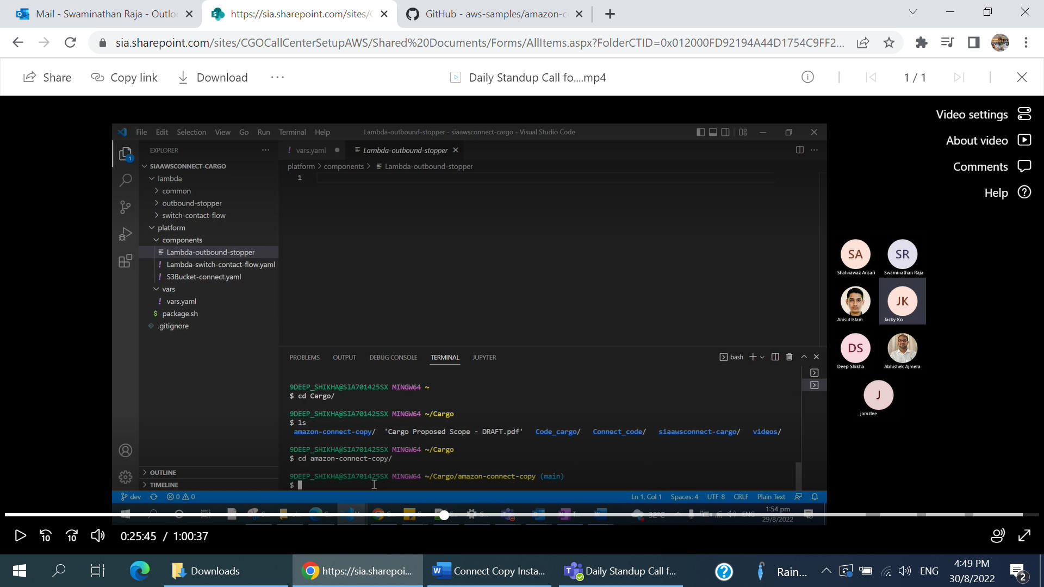

After this change of directory step, type in the

git clone <the copied link from the git hub> as below

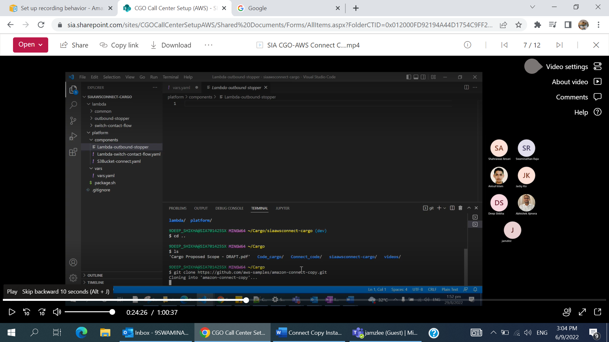

Once this command is typed in, the cloning will start.

After this step, change directory to amazon -connect-copy.

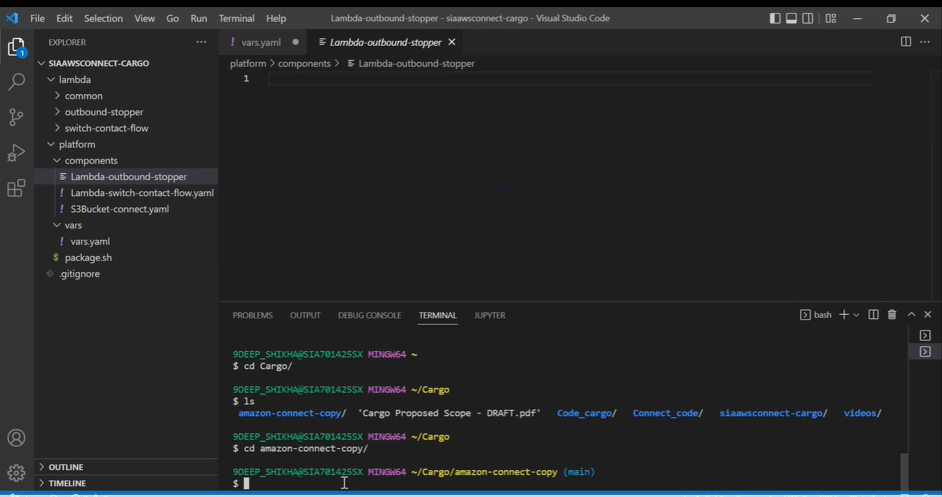

After this step, use the cp command to copy the **bin/\*** file over to another location (/usr/bin/) as below.

After this step, use the link

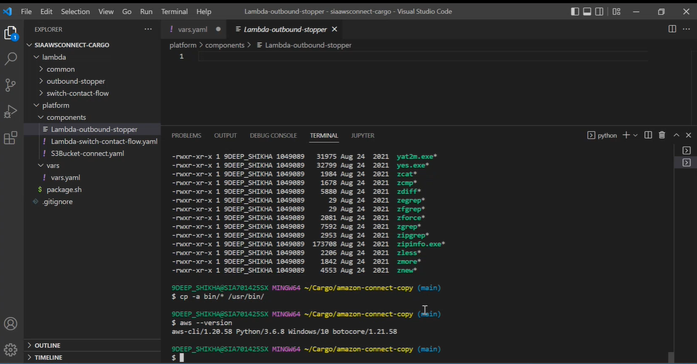

To Check if the aws cli has been installed correctly, type in aws - - version which will display the version correctly.

2. AWS CLI Installation

After this step, follow the instruction guide as per this link. ->

<https://docs.aws.amazon.com/cli/latest/userguide/getting-started-install.html>

After successfully installed, open command prompt and check the aws version by giving this input command. ( aws - - version )

It should successfully display the version of the awscli version.

3. JQ Installation steps

After this step, install the jq using the following steps from this link below.

<https://stedolan.github.io/jq/download/>

The preferred version would be jq 1.6 as it would be up to date.

After this step, open command prompt terminal in VSCode to check the jq version. ( jq - - version)

It should successfully display the version of the file downloaded.

Next Step is to copy the jq files to usr/bin location using the command of

**cp -a jq.exe /usr/bin/**

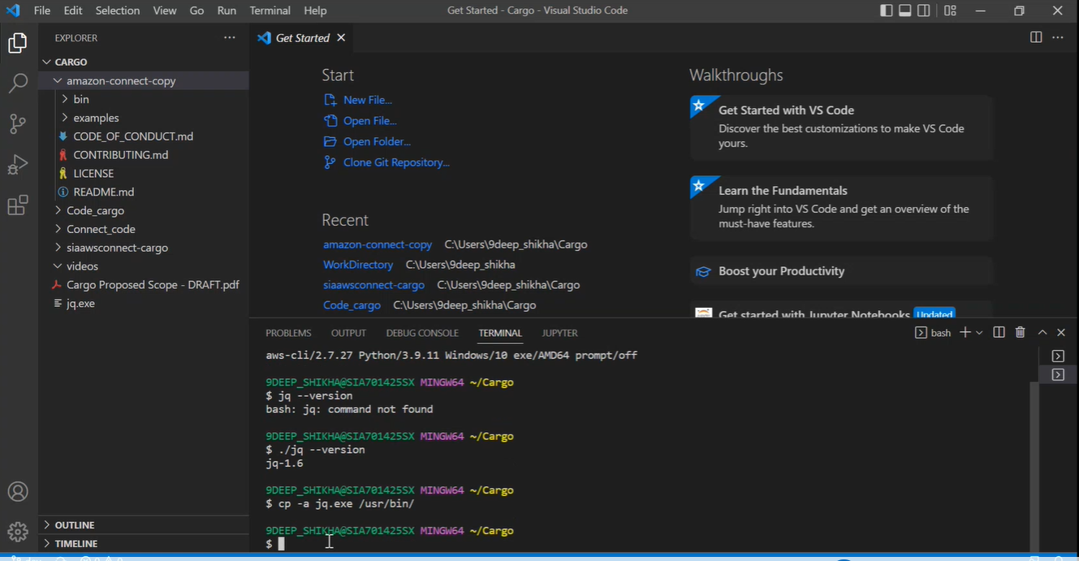

After this command, change directory to ~/Code using this following command.

**$ cd Code**

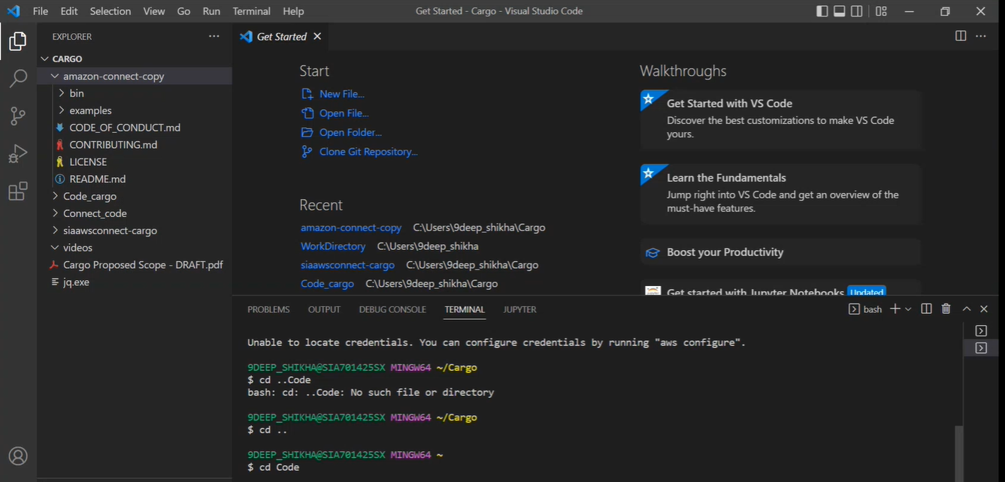

After changing directory, run the pipenv command for the python file. This will prompt the username and password as your win2kID and password.

9DEEP_SHIKHA@SIA701425SX MINGW64 ~/Code

$ pipenv run python samlapi_formauth.py

samlapi_formauth running...

Loading account profile data

Fetching SSO page https://sqauthprod.sq.com.sg/affwebservices/public/saml2sso?SPID=urn:amazon:webservices

Username:9deep_shikha

Password:

idpauthformsubmiturl https://sqauthprod.sq.com.sg/affwebservices/public/processlogin.jsp

Extracting data from SAML assertion...

Processing SAML into arns...

Please choose the role you would like to assume:

[1]: sia-auto arn:aws:iam::817929577935:role/SIAAWSCONNECT_CARGO_ADMIN

[2]: sia-auto arn:aws:iam::817929577935:role/SIAAWSCONNECT_CONNECT_DEVOPS

[3]: sia-auto arn:aws:iam::817929577935:role/CMC_AWSCONNECT_ADMIN

[4]: sia-auto arn:aws:iam::817929577935:role/CMC_AWSCONNECT_DEVOPS

[5]: sia-dev4 arn:aws:iam::187756823879:role/SIAAWSCONNECT_CARGO_CONNECT

[6]: sia-dev4 arn:aws:iam::187756823879:role/DEMO_APP_CONNECT

[7]: sia-dev4 arn:aws:iam::187756823879:role/CMC_AWSCONNECT_CONNECT

[8]: sia-dev4 arn:aws:iam::187756823879:role/CMC_AWS_CONNECT

[9]: sia-dev4 arn:aws:iam::187756823879:role/SIA_CloudOps

[10]: sia-dev4 arn:aws:iam::187756823879:role/SIA_DevOps

[11]: sia-dev4 arn:aws:iam::187756823879:role/ADMIN

[12]: sia-nonprodauto arn:aws:iam::378888410647:role/SIAAWSCONNECT_CARGO_ADMIN

[13]: sia-nonprodauto arn:aws:iam::378888410647:role/CMC_AWSCONNECT_CONNECT

[14]: sia-nonprodauto arn:aws:iam::378888410647:role/CMC_AWSCONNECT_DEVOPS

[15]: sia-nonprodauto arn:aws:iam::378888410647:role/CMC_AWSCONNECT_ADMIN

[16]: sia-poc5 arn:aws:iam::631062911682:role/ADMIN

[17]: sia-prodauto arn:aws:iam::654782598114:role/SIAAWSCONNECT_CARGO_ADMIN

[18]: sia-prodauto arn:aws:iam::654782598114:role/CMC_AWSCONNECT_CONNECT

[19]: sia-prodauto arn:aws:iam::654782598114:role/CMC_AWSCONNECT_ADMIN

[20]: sia-prodauto arn:aws:iam::654782598114:role/CMC_AWSCONNECT_DEVOPS

Selection:11

Requesting STS credentials for profile_name=sia-dev4, role_arn=arn:aws:iam::187756823879:role/ADMIN

Writing temp creds to C:\Users\9deep_shikha\.aws\credentials

----------------------------------------------------------------

Your new access key pair has been stored in the AWS configuration file C:\Users\9deep_shikha\.aws\credentials uml profile.

Note that it will expire at 22:12:38 29/Aug/22 Malay Peninsula Standard Time.

After this time, you may rerun this script to refresh your access key pair.

To use this credential, call the AWS CLI with the --profile option (e.g. aws --profile saml ec2 describe-instan

----------------------------------------------------------------

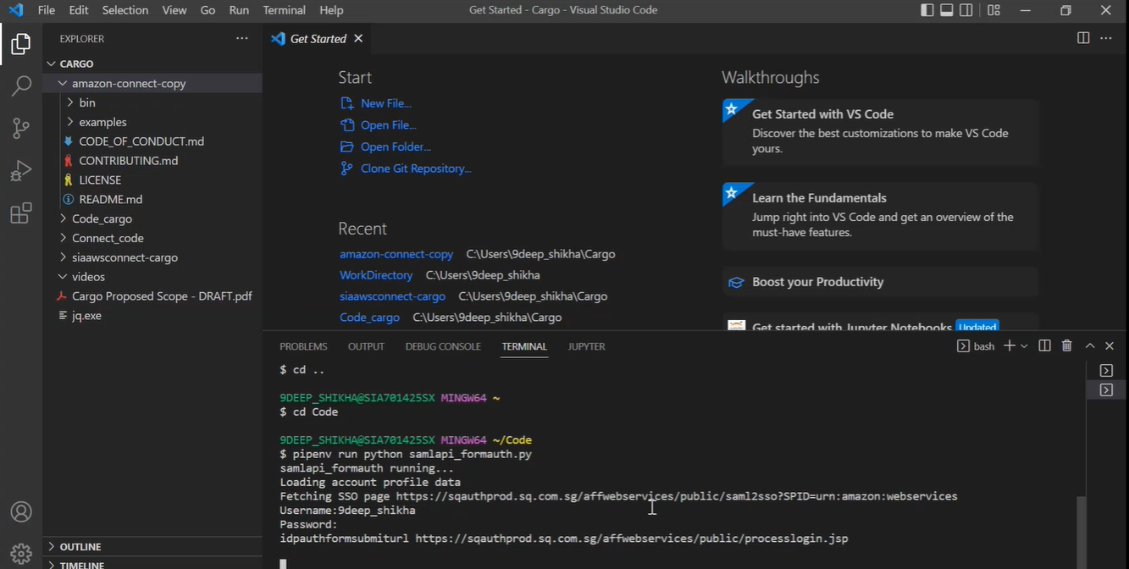

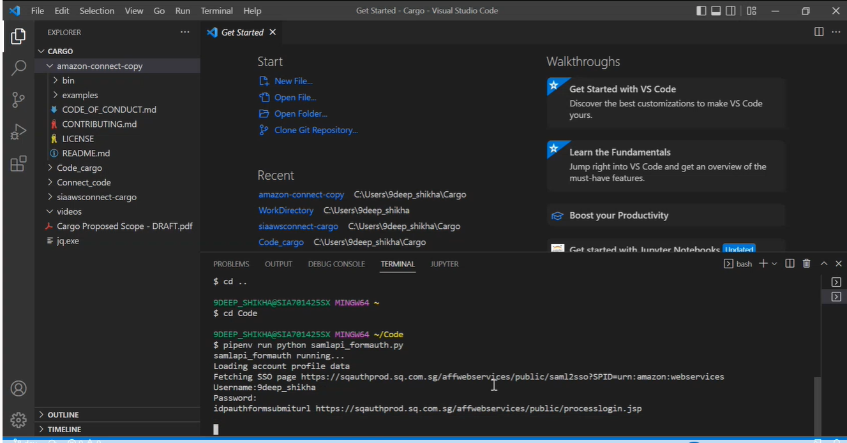

This will generate the different connect roles from which the user can select.

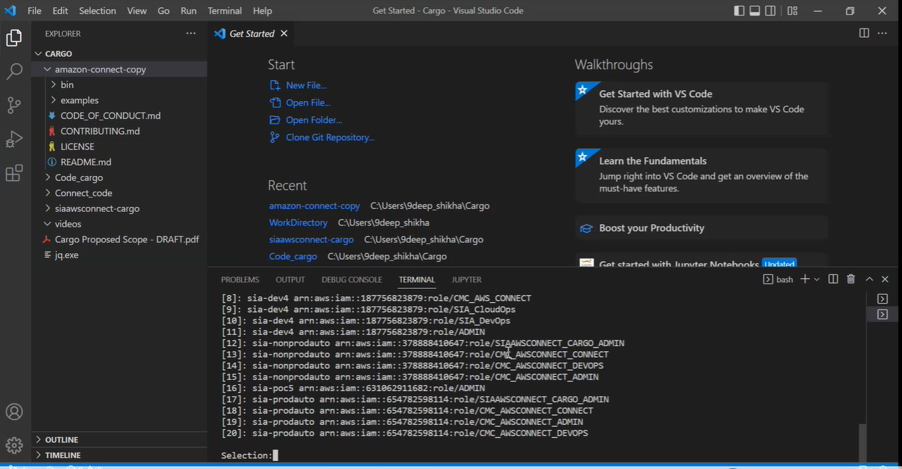

For example, if the user wants to check for the dev admin role, the selection number would be 11.

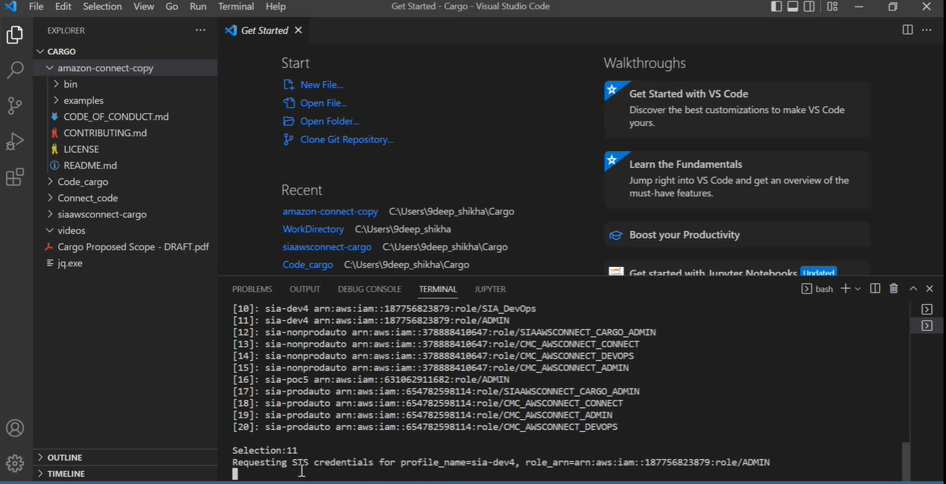

After this step, using the command : **$ aws s3 ls - -profile=saml** , it lists out the contents. The commands are as below and the output along with the screenshot.

9DEEP_SHIKHA@SIA701425SX MINGW64 ~/Code

$ aws s3 ls --profile=saml

2022-04-11 14:27:04 amazon-connect-6c51bcb24432

2021-10-04 11:51:17 amazon-connect-8b9b44353b41

2021-11-10 16:50:35 amazon-connect-942d2f6901ac

2022-04-11 16:19:49 amazon-connect-c436e64da8d5

2022-04-11 14:31:02 amazon-connect-ce3d062ddba4

2020-01-10 11:09:27 cf-templates-14j545h4nw7jh-ap-southeast-1

2021-11-09 11:28:17 cmc-awsconnect-dev-connect

2021-11-09 11:30:13 cmc-awsconnect-dev-interface

2022-08-08 09:39:13 core-compliance-dev4-elb-accesslogs

2022-08-08 09:39:18 core-compliance-dev4-s3-accesslogs

2021-11-02 17:03:36 demo-app-poc-cms-awsconnect-connect

2021-11-02 17:03:43 demo-app-poc-cms-awsconnect-interface

2021-11-02 17:03:04 demo-app-poc-cms-awsconnect-user-agent-onboard-list

2021-10-22 11:27:35 dev-siacmc-connect-187756823879

2021-10-28 05:53:05 dev-siacmc-deployment-187756823879

2021-10-23 05:20:40 dev-siacmc-interface-187756823879

2021-10-22 11:26:44 dev2-siacmc-connect-187756823879

2021-10-28 05:52:18 dev2-siacmc-deployment-187756823879

2021-10-23 05:20:19 dev2-siacmc-interface-187756823879

2020-06-13 03:10:21 elasticbeanstalk-ap-southeast-1-187756823879

2022-08-29 12:18:18 siaawsconnect-cargo-dev-connect

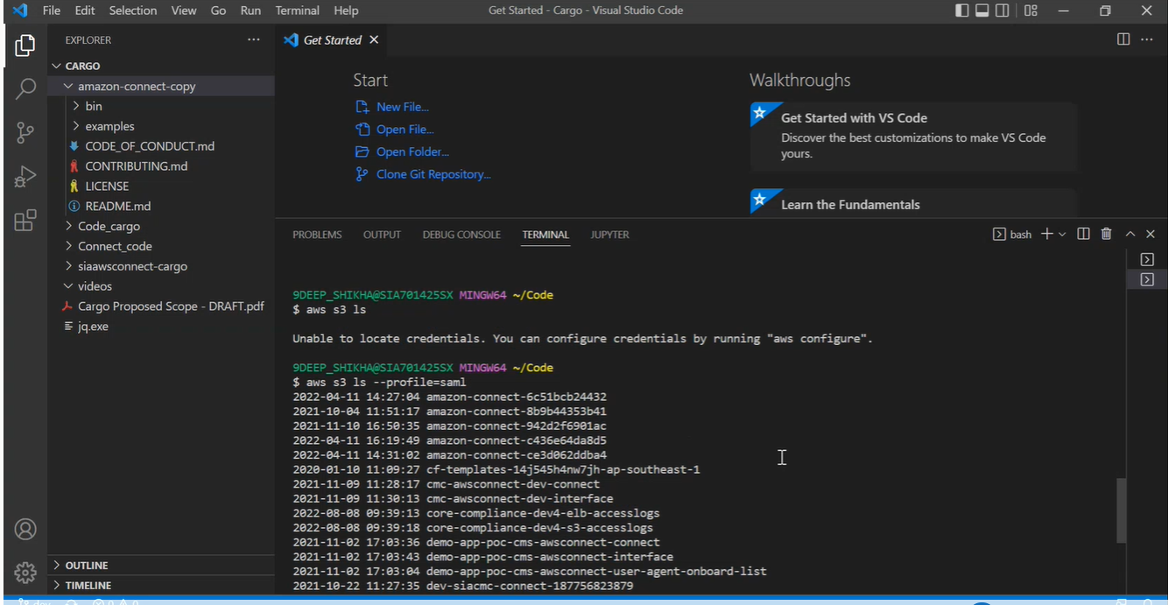

Now, after this step, change directory back to cargo.

**9DEEP_SHIKHA@SIA701425SX MINGW64 ~/Code**

**$ cd Cargo**

**bash: cd: Cargo: No such file or directory**

**9DEEP_SHIKHA@SIA701425SX MINGW64 ~/Code**

**$ ls**

**aws-extend-switch-roles.txt hello.txt Pipfile.lock test.py**

**decode.py output.xml samlapi_formauth.py* test2.py**

**dev2-siacmc-cms-receive-s3-b5957831-a47d-4f87-98ca-f2049a8e3a74.zip Pipfile sia-proxy.sh* unset-pr**

**9DEEP_SHIKHA@SIA701425SX MINGW64 ~/Code**

**$ cd ../Cargo/**

**9DEEP_SHIKHA@SIA701425SX MINGW64 ~/Cargo**

**$ ls**

**amazon-connect-copy/ Code_cargo/ jq.exe* videos/**

**'Cargo Proposed Scope - DRAFT.pdf' Connect_code/ siaawsconnect-cargo/**

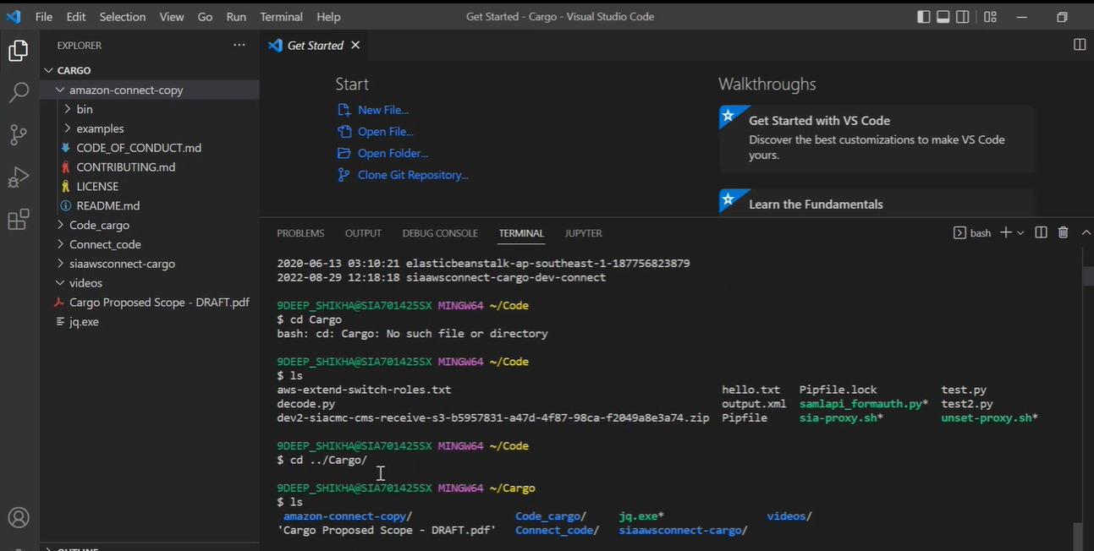

Next step, to list out the instances of the connect, Firstly export the profile using the command as below.

**$export AWS_PROFILE=saml**

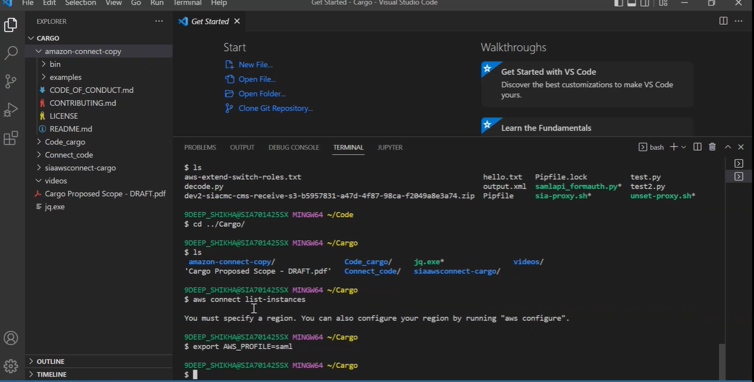

Next step is to use the command to list out instances.

**9DEEP_SHIKHA@SIA701425SX MINGW64 ~/Cargo**

**$ aws connect list-instances**

**You must specify a region. You can also configure your region by running "aws configure".**

**9DEEP_SHIKHA@SIA701425SX MINGW64 ~/Cargo**

**$ export AWS_PROFILE=saml**

**9DEEP_SHIKHA@SIA701425SX MINGW64 ~/Cargo**

**$ aws connect list-instances**

**{**

**"InstanceSummaryList": [**

**{**

**"Id": "4d1a0282-72b0-4dbf-b472-b9ffea1507eb",**

**"Arn": "arn:aws:connect:ap-southeast-1:187756823879:instance/4d1a0282-72b0-4dbf-b472-b9ffea1507eb",**

**"IdentityManagementType": "SAML",**

**"InstanceAlias": "dev-siacmc-connect",**

**"CreatedTime": "2021-09-08T16:16:00+08:00",**

**"ServiceRole": "arn:aws:iam::187756823879:role/aws-service-role/connect.amazonaws.com/AWSServiceRolonnect_vbm7Nwqhz30gW5xzBvlb",**

**"InstanceStatus": "ACTIVE",**

**"InboundCallsEnabled": true,**

**"OutboundCallsEnabled": true**

**},**

**{**

**"Id": "85ca0375-18c8-4fac-895f-aa23e418c899",**

**"Arn": "arn:aws:connect:ap-southeast-1:187756823879:instance/85ca0375-18c8-4fac-895f-aa23e418c899",**

**"IdentityManagementType": "SAML",**

**"InstanceAlias": "demo-app-connect",**

**"CreatedTime": "2022-04-11T16:18:49+08:00",**

**"ServiceRole": "arn:aws:iam::187756823879:role/aws-service-role/connect.amazonaws.com/AWSServiceRolonnect_Qq2VFHzJ4UhixSpKzR2e",**

**"InstanceStatus": "ACTIVE",**

**"InboundCallsEnabled": true,**

**"OutboundCallsEnabled": true**

**},**

**{**

**"Id": "95e1bfdc-1464-4edf-8028-26a53885cd19",**

**"Arn": "arn:aws:connect:ap-southeast-1:187756823879:instance/95e1bfdc-1464-4edf-8028-26a53885cd19",**

**"IdentityManagementType": "SAML",**

**"InstanceAlias": "cmc-awsconnect-dev",**

**"CreatedTime": "2021-10-18T10:40:16+08:00",**

**"ServiceRole": "arn:aws:iam::187756823879:role/aws-service-role/connect.amazonaws.com/AWSServiceRolonnect_gGQeXUhslKgrKjYQ4Pf4",**

**"InstanceStatus": "ACTIVE",**

**"InboundCallsEnabled": true,**

**"OutboundCallsEnabled": true**

**},**

**{**

**"Id": "e0fe99ba-1dcb-40d5-bef5-60a6c248fa64",**

**"Arn": "arn:aws:connect:ap-southeast-1:187756823879:instance/e0fe99ba-1dcb-40d5-bef5-60a6c248fa64",**

**"IdentityManagementType": "CONNECT_MANAGED",**

**"InstanceAlias": "dev2-siacmc-connect",**

**"CreatedTime": "2021-09-23T13:21:33+08:00",**

**"ServiceRole": "arn:aws:iam::187756823879:role/aws-service-role/connect.amazonaws.com/AWSServiceRolonnect_czNZeL1OHywR6W8uvEC4",**

**"InstanceStatus": "ACTIVE",**

**"InboundCallsEnabled": true,**

**"OutboundCallsEnabled": true**

**},**

**{**

**"Id": "ec7cb86d-22c7-4ed0-875b-df6ef1a828de",**

**"Arn": "arn:aws:connect:ap-southeast-1:187756823879:instance/ec7cb86d-22c7-4ed0-875b-df6ef1a828de",**

**"IdentityManagementType": "SAML",**

**"InstanceAlias": "siaawsconnect-cargo-dev",**

**"CreatedTime": "2022-08-11T11:42:03+08:00",**

**"ServiceRole": "arn:aws:iam::187756823879:role/aws-service-role/connect.amazonaws.com/AWSServiceRolonnect_XdHInSJV8CpaHf4qZZjK",**

**"InstanceStatus": "ACTIVE",**

**"InboundCallsEnabled": true,**

**"OutboundCallsEnabled": true**

**}**

**]**

**}**

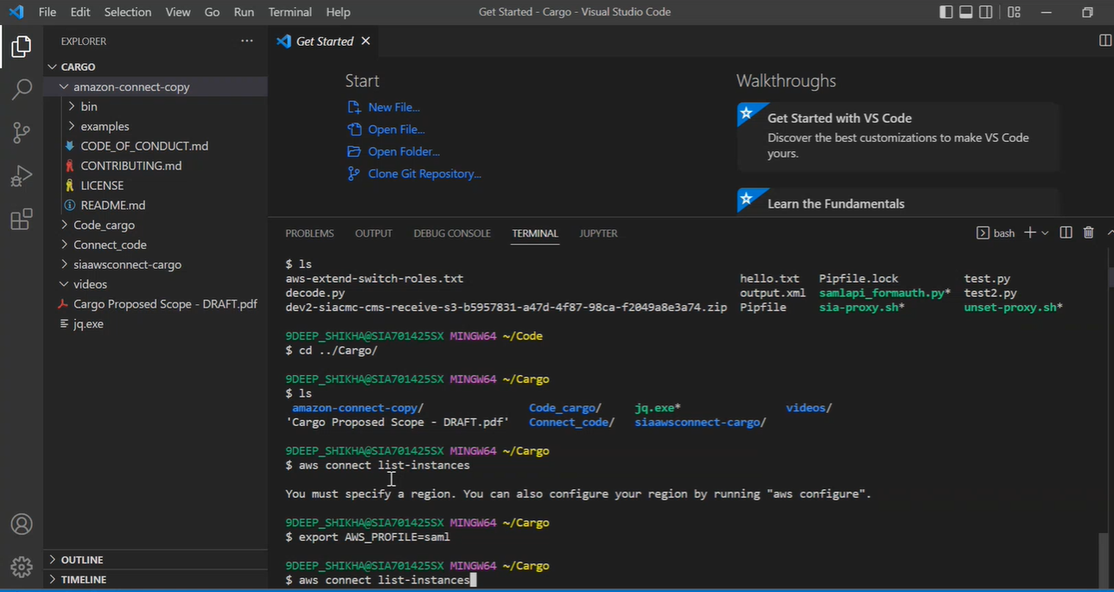

This will display out the summary list of all the instances.

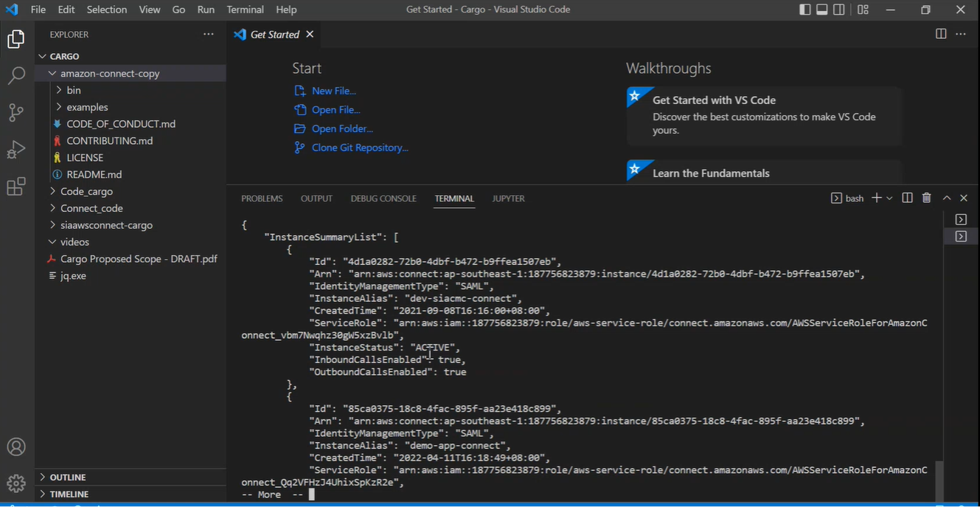

The following command below will make use of the jq command for the instance summary list which will list out details such as the ARN, Id, the status of the instance, enabled inboud and outbound calls status etc.

**9DEEP_SHIKHA@SIA701425SX MINGW64 ~/Cargo**

**$ aws connect list-instances| jq .InstanceSummaryList[]**

**{**

**"Id": "4d1a0282-72b0-4dbf-b472-b9ffea1507eb",**

**"Arn": "arn:aws:connect:ap-southeast-1:187756823879:instance/4d1a0282-72b0-4dbf-b472-b9ffea1507eb",**

**"IdentityManagementType": "SAML",**

**"InstanceAlias": "dev-siacmc-connect",**

**"CreatedTime": "2021-09-08T16:16:00+08:00",**

**"ServiceRole": "arn:aws:iam::187756823879:role/aws-service-role/connect.amazonaws.com/AWSServiceRoleForAmazon7Nwqhz30gW5xzBvlb",**

**"InstanceStatus": "ACTIVE",**

**"InboundCallsEnabled": true,**

**"OutboundCallsEnabled": true**

**}**

**{**

**"Id": "85ca0375-18c8-4fac-895f-aa23e418c899",**

**"Arn": "arn:aws:connect:ap-southeast-1:187756823879:instance/85ca0375-18c8-4fac-895f-aa23e418c899",**

**"IdentityManagementType": "SAML",**

**"InstanceAlias": "demo-app-connect",**

**"CreatedTime": "2022-04-11T16:18:49+08:00",**

**"ServiceRole": "arn:aws:iam::187756823879:role/aws-service-role/connect.amazonaws.com/AWSServiceRoleForAmazonVFHzJ4UhixSpKzR2e",**

**"InstanceStatus": "ACTIVE",**

**"InboundCallsEnabled": true,**

**"OutboundCallsEnabled": true**

**}**

**{**

**"Id": "95e1bfdc-1464-4edf-8028-26a53885cd19",**

**"Arn": "arn:aws:connect:ap-southeast-1:187756823879:instance/95e1bfdc-1464-4edf-8028-26a53885cd19",**

**"IdentityManagementType": "SAML",**

**"InstanceAlias": "cmc-awsconnect-dev",**

**"CreatedTime": "2021-10-18T10:40:16+08:00",**

**"ServiceRole": "arn:aws:iam::187756823879:role/aws-service-role/connect.amazonaws.com/AWSServiceRoleForAmazoneXUhslKgrKjYQ4Pf4",**

**"InstanceStatus": "ACTIVE",**

**"InboundCallsEnabled": true,**

**"OutboundCallsEnabled": true**

**}**

**{**

**"Id": "e0fe99ba-1dcb-40d5-bef5-60a6c248fa64",**

**"Arn": "arn:aws:connect:ap-southeast-1:187756823879:instance/e0fe99ba-1dcb-40d5-bef5-60a6c248fa64",**

**"IdentityManagementType": "CONNECT_MANAGED",**

**"InstanceAlias": "dev2-siacmc-connect",**

**"CreatedTime": "2021-09-23T13:21:33+08:00",**

**"ServiceRole": "arn:aws:iam::187756823879:role/aws-service-role/connect.amazonaws.com/AWSServiceRoleForAmazonZeL1OHywR6W8uvEC4",**

**"InstanceStatus": "ACTIVE",**

**"InboundCallsEnabled": true,**

**"OutboundCallsEnabled": true**

**}**

**{**

**"Id": "ec7cb86d-22c7-4ed0-875b-df6ef1a828de",**

**"Arn": "arn:aws:connect:ap-southeast-1:187756823879:instance/ec7cb86d-22c7-4ed0-875b-df6ef1a828de",**

**"IdentityManagementType": "SAML",**

**"InstanceAlias": "siaawsconnect-cargo-dev",**

**"CreatedTime": "2022-08-11T11:42:03+08:00",**

**"ServiceRole": "arn:aws:iam::187756823879:role/aws-service-role/connect.amazonaws.com/AWSServiceRoleForAmazonInSJV8CpaHf4qZZjK",**

**"InstanceStatus": "ACTIVE",**

**"InboundCallsEnabled": true,**

**"OutboundCallsEnabled": true**

**}**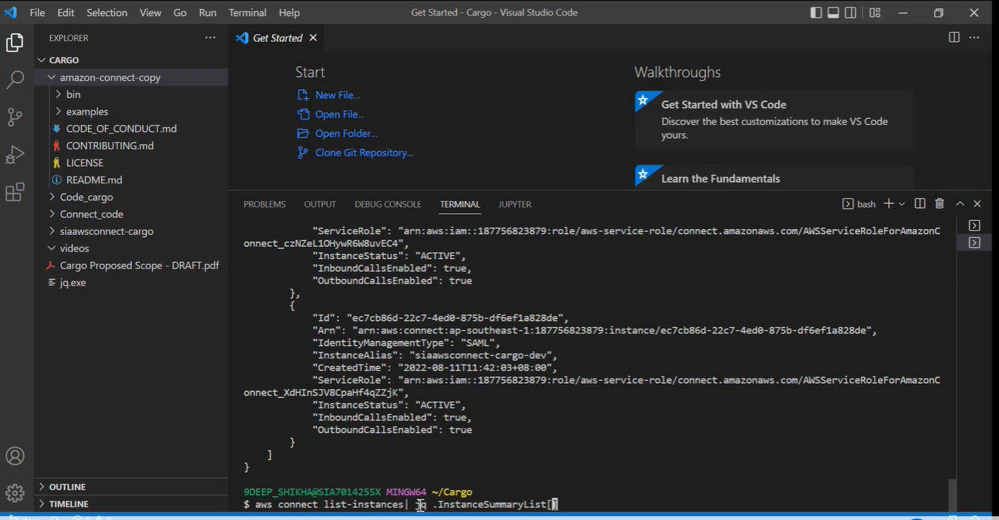

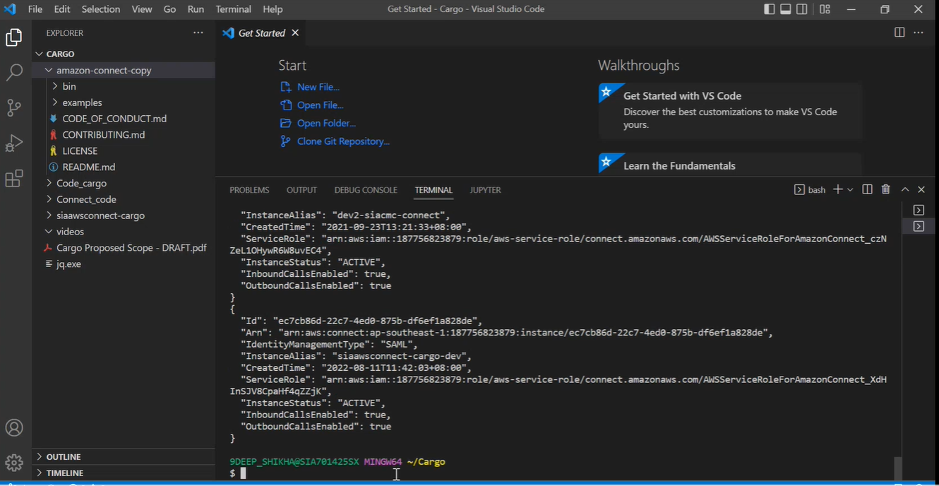

The following command below makes sure that the aws command line and jq works.

**9DEEP_SHIKHA@SIA701425SX MINGW64 ~/Cargo**

**$ aws connect list-instances| jq .InstanceSummaryList[].InstanceAlias**

**"dev-siacmc-connect"**

**"demo-app-connect"**

**"cmc-awsconnect-dev"**

**"dev2-siacmc-connect"**

**"siaawsconnect-cargo-dev"**

**9DEEP_SHIKHA@SIA701425SX MINGW64 ~/Cargo**

**$ ls**

**amazon-connect-copy/ Code_cargo/ jq.exe* videos/**

**'Cargo Proposed Scope - DRAFT.pdf' Connect_code/ siaawsconnect-cargo/**

**9DEEP_SHIKHA@SIA701425SX MINGW64 ~/Cargo**

**$ connect_save**

**Usage: connect_save [-?fsev] [-p aws_profile] [-c contact_flow_prefix] [-G ignore_prefix] instance_alias**

**Retrieve components from an Amazon Connect instance into plain files**

**instance_alias Alias of the Connect instance (or path to the directory to save, with the alias beiname)**

**-f Force removal of existing instance_alias directory**

**-s Skip unpublished contact flow modules and contact flows with an error (instead of f**

**-e Proceed even when the system may not encode Extended ASCII characters properly**

**-v Show version of this script**

**-p profile AWS Profile to use**

**-c contact_flow_prefix Prefix of Contact Flows and Modules to be copied (all others will be ignored) - Def**

**copy all**

**-G ignore_prefix Ignore hours, queues, routing profiles, flows or modules with names prefixed with ix**

**-C codepage Override the auto-detected codepage (e.g., use '-C CP1252' for Gitbash ANSI if expecoding issues)**

**-? Help**

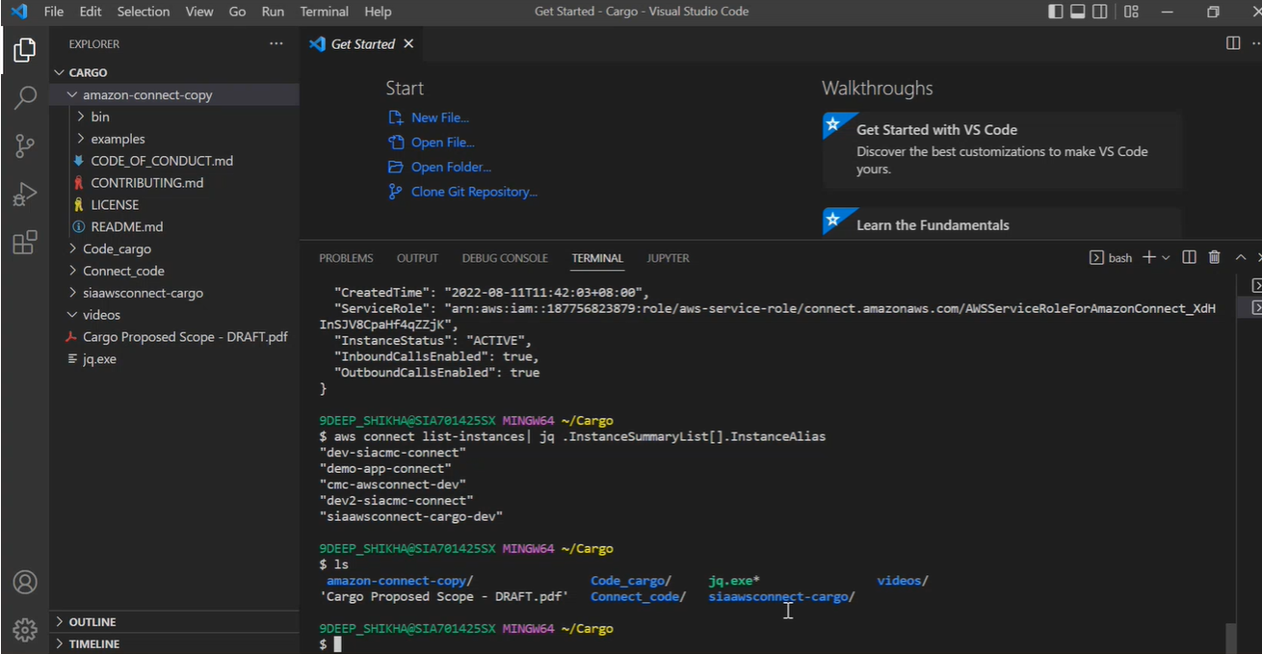

The connect save command below shows the user of the usability of the commands.

**$ connect_save**

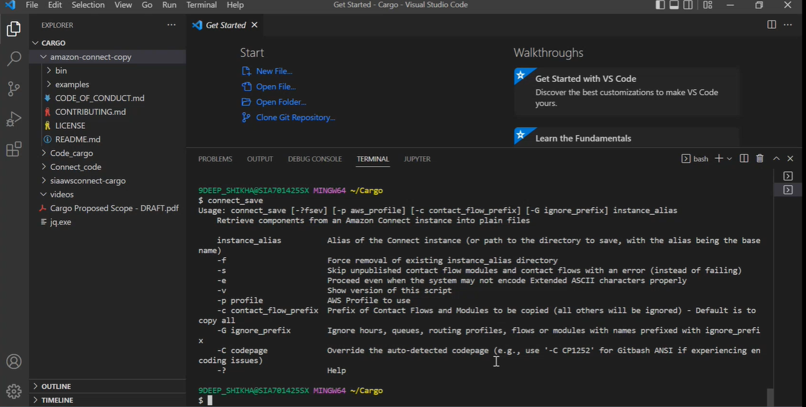

Next step is such that the files will be saved and exported.

**9DEEP_SHIKHA@SIA701425SX MINGW64 ~/Cargo**

**$ connect_save -f -c SIA siaawsconnect-cargo-dev**

**Instance Alias: siaawsconnect-cargo-dev (in directory "siaawsconnect-cargo-dev")**

**AWS Profile: saml**

**Contact Flow Prefix: SIA**

**Instance ID: ec7cb86d-22c7-4ed0-875b-df6ef1a828de**

**7 prompts listed in "siaawsconnect-cargo-dev/prompts.json"**

**1 hours of operations listed in "siaawsconnect-cargo-dev/hours.json"**

**Exporting hours of operation Basic Hours**

**1 queues listed in "siaawsconnect-cargo-dev/queues.json"**

**Exporting queue BasicQueue**

**1 routing profiles listed in "siaawsconnect-cargo-dev/routings.json"**

**Exporting routing profile Basic Routing Profile**

**0 contact flow modules listed in "siaawsconnect-cargo-dev/modules.json" with names prefixed with "SIA" or Defau**

**8 contact flows listed in "siaawsconnect-cargo-dev/flows.json" with names prefixed with "SIA" or Default**

**Exporting contact flow Default agent hold**

**Exporting contact flow Default agent transfer**

**Exporting contact flow Default agent whisper**

**Exporting contact flow Default customer hold**

**Exporting contact flow Default customer queue**

**Exporting contact flow Default customer whisper**

**Exporting contact flow Default outbound**

**Exporting contact flow Default queue transfer**

**All done**

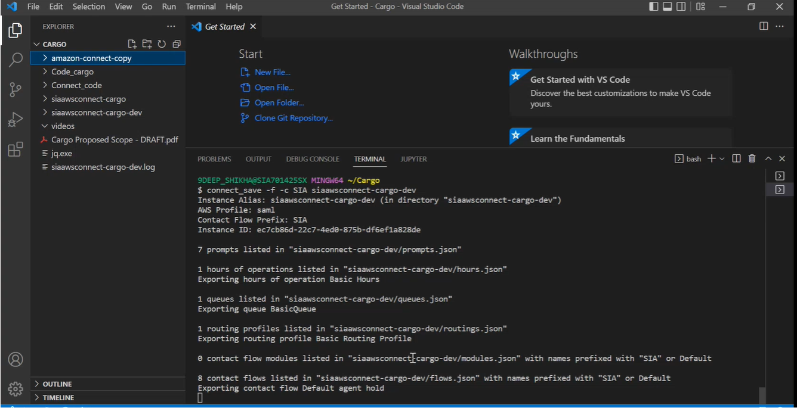

This shows that cargo is source and dev is the destination where the files are export and saved to.

The next following command will do a similar check.

This checks for all the details such as contact flows, prompts, Hours of operation, Routing profiles, Contact Flow modules, queues and etc. The helper files are created in this process as well as the helper command was being used.

**9DEEP_SHIKHA@SIA701425SX MINGW64 ~/Cargo**

$ connect_diff

Usage: connect_diff [-?fev] [-l lambda_prefix_a=lambda_prefix_b] [-b lex_bot_prefix_a=lex_bot_prefix_b] instancnstance_alias_b helper

Based on connect_save result on Amazon Connect instance A and B,

find the differences and produce helper files to safely copy components from A to B.

instance_alias_a Alias of the Connect instance A

instance_alias_b Alias of the Connect instance B

(Aliases can be a path to the directory where the instance was saved using connect_save

helper Name of the helper directory

-f Force removal of existing helper directory

-e Proceed even when the system may not encode Extended ASCII characters properly

-v Show version of this script

-l lambda_prefix_a=lambda_prefix_b

Lambda function name prefixes for instances A and B (if different) to be replaced durin

-b lex_bot_prefix_a=lex_bot_prefix_b

Lex bot (Classic) name prefixes for instances A and B (if different) to be replaced dur -? Help

Note: This script create files in the helper directory without changing any instance component files.

9DEEP_SHIKHA@SIA701425SX MINGW64 ~/Cargo

$ connect_diff -f

Usage: connect_diff [-?fev] [-l lambda_prefix_a=lambda_prefix_b] [-b lex_bot_prefix_a=lex_bot_prefix_b] instancnstance_alias_b helper

Based on connect_save result on Amazon Connect instance A and B,

instance_alias_a Alias of the Connect instance A

instance_alias_b Alias of the Connect instance B

(Aliases can be a path to the directory where the instance was saved using connect_save.)

helper Name of the helper directory

-f Force removal of existing helper directory

-e Proceed even when the system may not encode Extended ASCII characters properly

-v Show version of this script

-l lambda_prefix_a=lambda_prefix_b

Lambda function name prefixes for instances A and B (if different) to be replaced during copying

-b lex_bot_prefix_a=lex_bot_prefix_b

Lex bot (Classic) name prefixes for instances A and B (if different) to be replaced during copying -? Help

Note: This script create files in the helper directory without changing any instance component files.

9DEEP_SHIKHA@SIA701425SX MINGW64 ~/Cargo

$ connect_diff -f siaawsconnect-cargo

siaawsconnect-cargo/ siaawsconnect-cargo-dev/ siaawsconnect-cargo-dev.log

9DEEP_SHIKHA@SIA701425SX MINGW64 ~/Cargo

$ connect_diff -f Connect_code/sia-cargo-demo siaawsconnect-cargo-dev helper

Instance Alias A: sia-cargo-demo (in directory "Connect_code/sia-cargo-demo")

Instance Alias B: siaawsconnect-cargo-dev (in directory "siaawsconnect-cargo-dev")

Helper: helper

instance_alias_a="sia-cargo-demo"

instance_alias_dir_a="Connect_code/sia-cargo-demo"

instance_alias_b="siaawsconnect-cargo-dev"

instance_alias_dir_b="siaawsconnect-cargo-dev"

instance_id_a="35054040-00c6-48a7-8658-1ff6310d37e4"

instance_arn_a="arn:aws:connect:ap-southeast-1:785828657109:instance/35054040-00c6-48a7-8658-1ff6310d37e4"

region_a="ap-southeast-1"

aws_ac_a="785828657109"

aws_profile_a=""

lambda_prefix_a=""

lex_bot_prefix_a=""

instance_id_b="ec7cb86d-22c7-4ed0-875b-df6ef1a828de"

instance_arn_b="arn:aws:connect:ap-southeast-1:187756823879:instance/ec7cb86d-22c7-4ed0-875b-df6ef1a828de"

region_b="ap-southeast-1"

aws_ac_b="187756823879"

aws_profile_b=""

lambda_prefix_b=""

lex_bot_prefix_b=""

contact_flow_prefix="SIA"

Checking Prompts ...

Checking Hours of operations ...

Checking Queues ...

Checking Routing Profiles ...

Checking Contact Flow Modules ...

Checking Contact Flows ...

These helper files are created:

helper/helper.var: About the source and target Amazon Connect instances

helper/helper.new: Components to add to "siaawsconnect-cargo-dev"

helper/helper.old: Components to update for "siaawsconnect-cargo-dev" based on "Connect_code/sia-cargo-demo"

helper/helper.sed: SED script used to update components

helper/flow_template.json: Contact Flow template json

All done

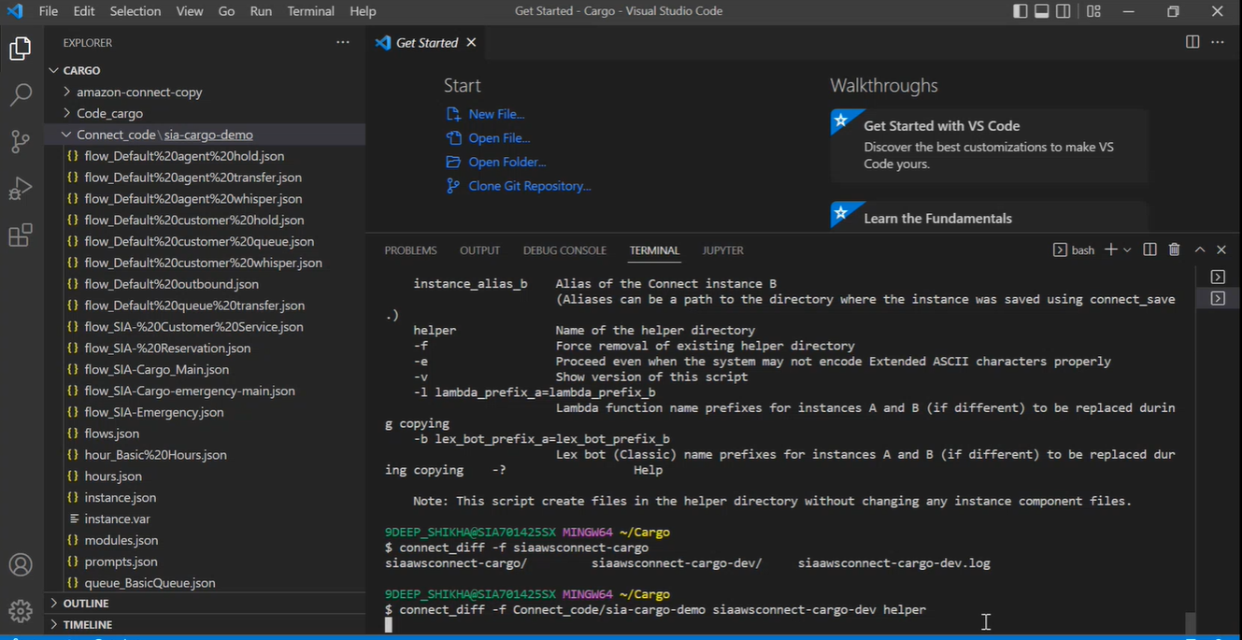

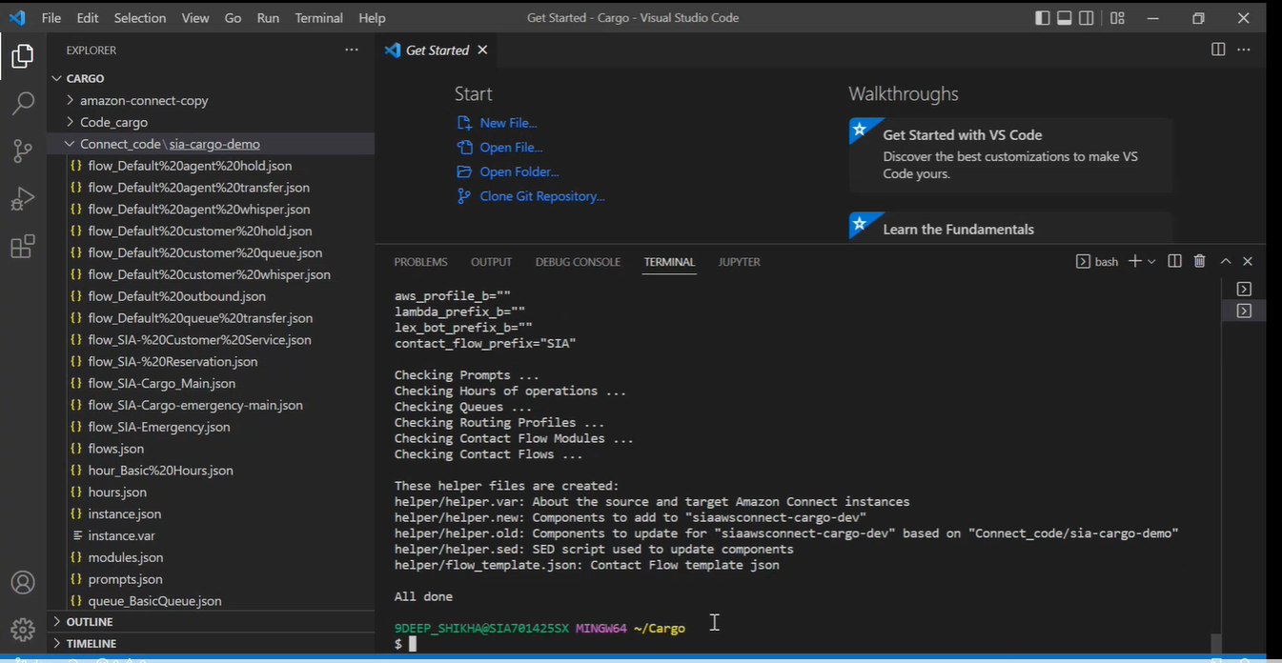

After this step, the copy command for helper is used to create the queues and contact flows file. This command will copy over the files in the queue and contact flows.

9DEEP_SHIKHA@SIA701425SX MINGW64 ~/Cargo

$ connect_copy

Usage: connect_copy [-?dev] helper

Copy Amazon Connect instance A to instance B safely, based on the

connect_save and connect_diff results, under the helper directory

creating new components in helper.new, updating old components in helper.old,

and updating references defined in helper.sed.

helper Name of the helper directory

-d Dry run - Run through the script but not updating the target instance

-e Proceed even when the system may not encode Extended ASCII characters properly

-v Show version of this script

-? Help

9DEEP_SHIKHA@SIA701425SX MINGW64 ~/Cargo

$ connect_copy helper

Instance Alias A: sia-cargo-demo (in directory "Connect_code/sia-cargo-demo")

Instance Alias B: siaawsconnect-cargo-dev (in directory "siaawsconnect-cargo-dev")

Helper Directory: helper

AWS Profile B in use: saml

Context Flow Prefix: SIA

Prompts

-------

All prompts in the source instance exist in the target instance.

Hours of operations

-------------------

No hours of operations to create

Checking 1 hours of operations for an update

1. hour_Basic%20Hours.json ... changed

Updating hour_Basic%20Hours.json

Queues

------

Creating 2 queues

1. queue_SIA%20Customer%20Services.json

2. queue_SIA%20Reservation.json

Checking 1 queues for an update

1. queue_BasicQueue.json ... same

Routing Profiles

----------------

Creating 2 routing profiles

1. routing_SIA%20Customer%20Services.json

2. routing_SIA%20Reservation.json

Checking 2 routing profiles for an update

1. routing_SIA%20Customer%20Services.json ... same

2. routing_SIA%20Reservation.json ... same

Contact Flow Modules Creation

-----------------------------

No contact flow modules with names prefixed with "SIA" to create

Contact Flow Modules Update

---------------------------

No contact flow modules to update

Contact Flows Creation

----------------------

Creating 5 contact flows with names prefixed with "SIA"

1. flow_SIA-%20Customer%20Service.json

2. flow_SIA-%20Reservation.json

3. flow_SIA-Cargo_Main.json

4. flow_SIA-Cargo-emergency-main.json

5. flow_SIA-Emergency.json

Contact Flows Update

--------------------

Checking 5 contact flows with names prefixed with "SIA" for an update

1. flow_SIA-%20Customer%20Service.json ... changed

2. flow_SIA-%20Reservation.json ... changed

3. flow_SIA-Cargo_Main.json ... changed

4. flow_SIA-Cargo-emergency-main.json ... changed

5. flow_SIA-Emergency.json ... changed

15 actions on the target instance

The AWS CLI commands carrying out such actions can be found in: helper.log

All done

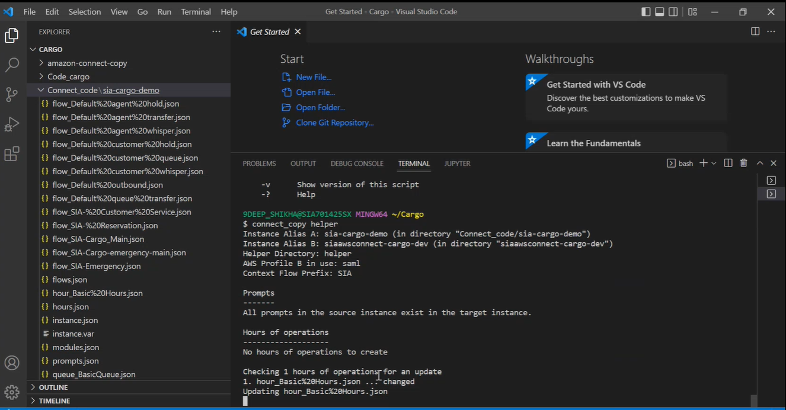

Once the file is copied over successfully, it will show that in the interface of the console.

The below commands shows the summary list.

9DEEP_SHIKHA@SIA701425SX MINGW64 ~/Cargo

aws connect list-phone-numbers --instance-id ec7cb86d-22c7-4ed0-875b-df6ef1a828de --profile=saml

9DEEP_SHIKHA@SIA701425SX MINGW64 ~/Code

$ aws connect list-phone-numbers --instance-id ec7cb86d-22c7-4ed0-875b-df6ef1a828de --profile=saml

{

"PhoneNumberSummaryList": [

{

"Id": "b97aac80-c19a-4d63-903d-d747f0294532",

"Arn": "arn:aws:connect:ap-southeast-1:187756823879:instance/ec7cb86d-22c7-4ed0-875b-df6ef1a828de/phone-number/b97aac80-c19a-4d63-903d-d747f0294532",

"PhoneNumber": "+6560162668",

"PhoneNumberType": "DID",

"PhoneNumberCountryCode": "SG"

},

{

"Id": "dd176b4b-9871-4424-9f38-0fabd93e3f0d",

"Arn": "arn:aws:connect:ap-southeast-1:187756823879:instance/ec7cb86d-22c7-4ed0-875b-df6ef1a828de/phone-number/dd176b4b-9871-4424-9f38-0fabd93e3f0d",

"PhoneNumber": "+611800320827",

"PhoneNumberType": "TOLL_FREE",

"PhoneNumberCountryCode": "AU"

}

]

}

After this step, log in to the cargo dev admin account using this link.

<https://sqauthprod.sq.com.sg/affwebservices/public/dologin.jsp?TYPE=33554432&REALMOID=06-9f48f6a5-0474-4bdd-9cd8-e26553966e3f&GUID=&SMAUTHREASON=0&METHOD=GET&SMAGENTNAME=-SM-rEnAZmTieNrY0GvIrtYWIliW%2bjFIRXb0b9OrXfgxa6CbRo7D3cAgMNKCUoQON4Ew3hPyPsZIxksa%2f3%2fr2VoN2e8yL7o%2bKoQG&TARGET=-SM-HTTPS%3a%2f%2fsqauthprod%2esq%2ecom%2esg%2faffwebservices%2fredirectjsp%2fredirect%2ejsp%3fSPID%3durn%3aamazon%3awebservices%26SMPORTALURL%3dhttps-%3A-%2F-%2Fsqauthprod%2esq%2ecom%2esg-%2Faffwebservices-%2Fpublic-%2Fsaml2sso%26SAMLTRANSACTIONID%3de6210d09--2abda0eb--28f776f0--ed07066a--96f50104--b0>

Log in to this account as an admin.

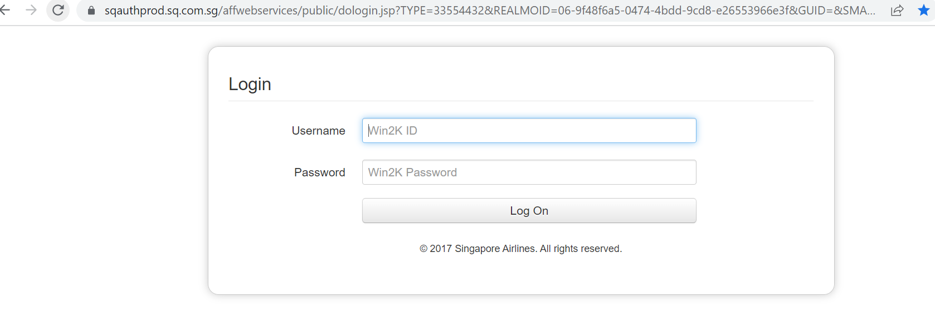

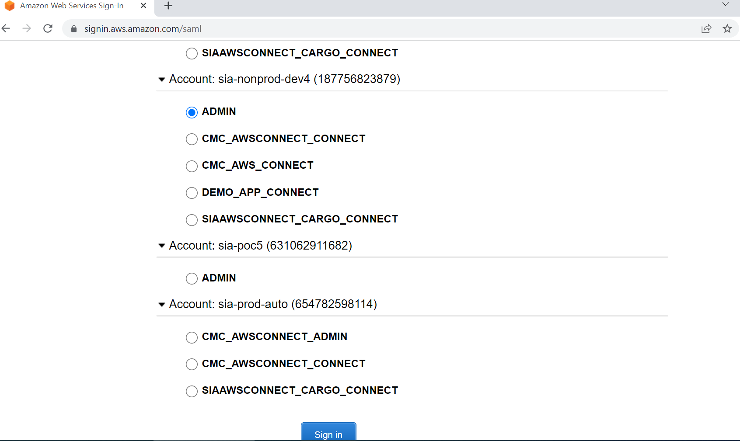

Click on amazon connect.

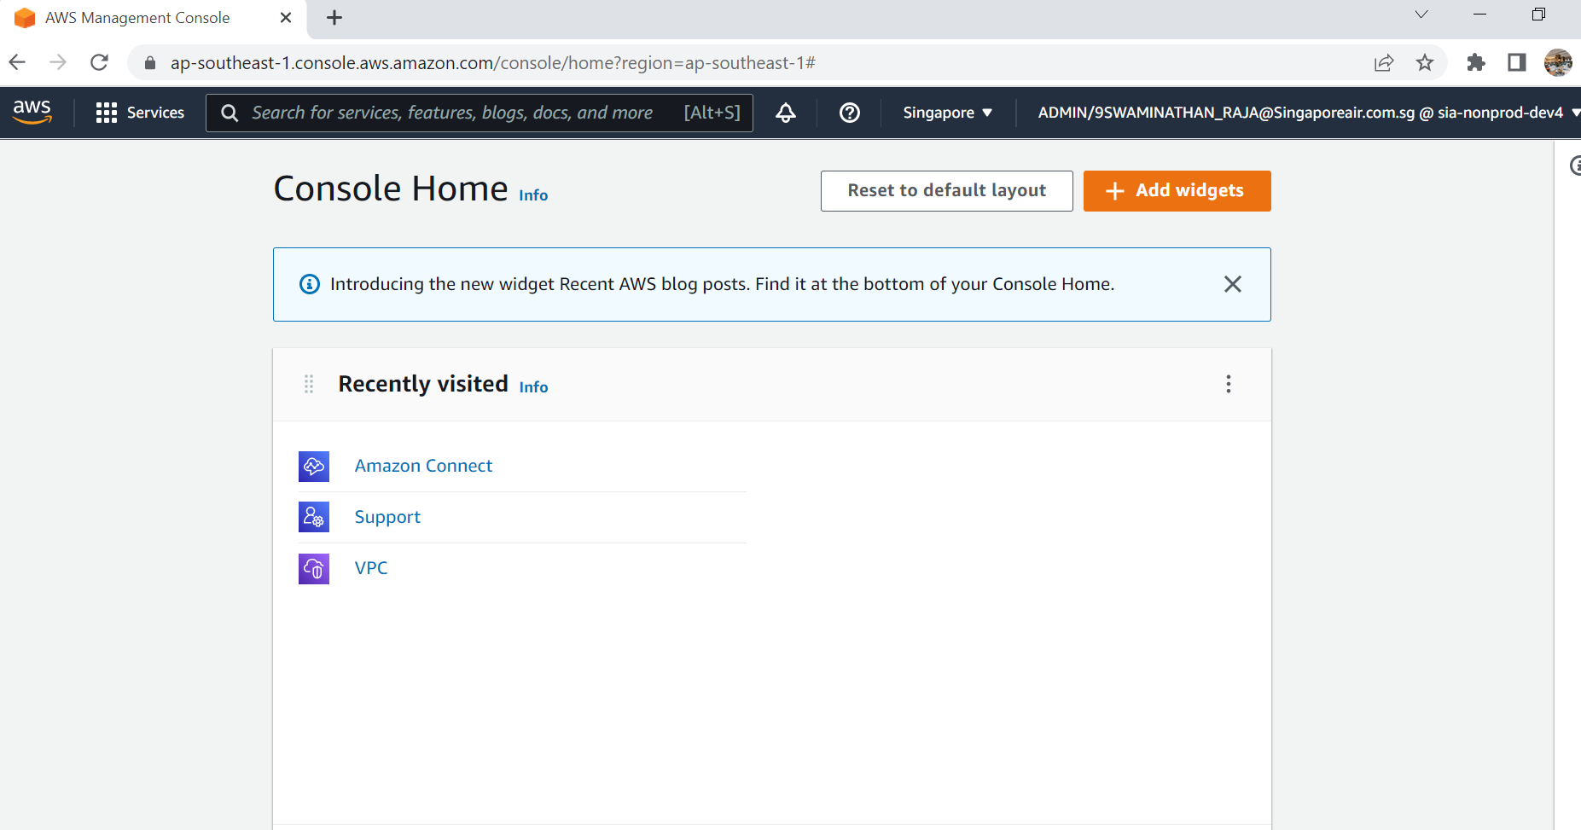

Click on cargo link on the first one.

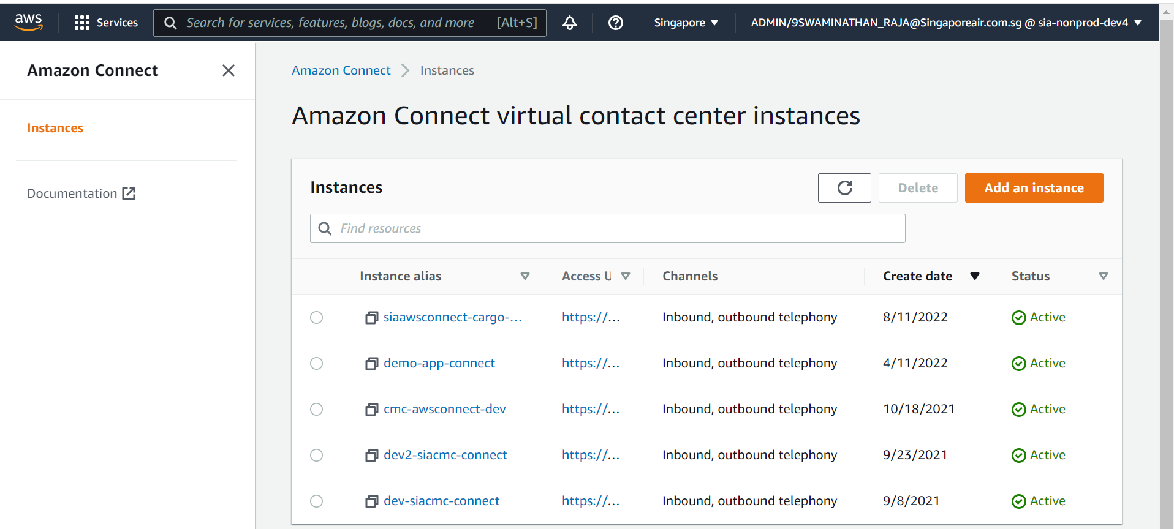

After clicking cargo connect link, click on log in for emergency access. (Usually this emergency access link is not used unless there is a need to).

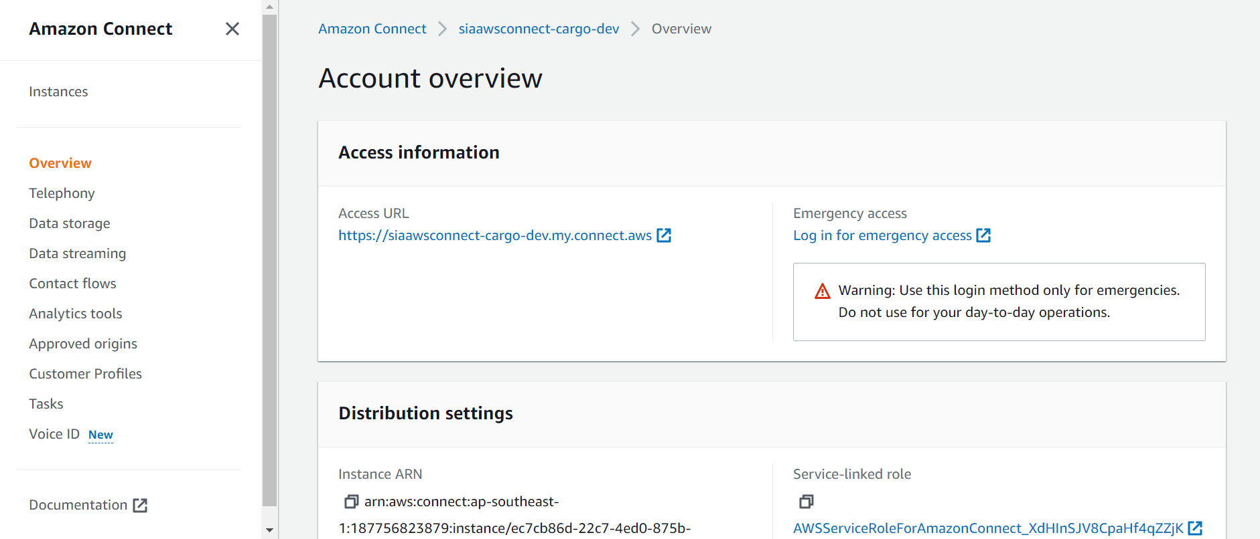

Under queues, we can see the reservation and customer service has been created.

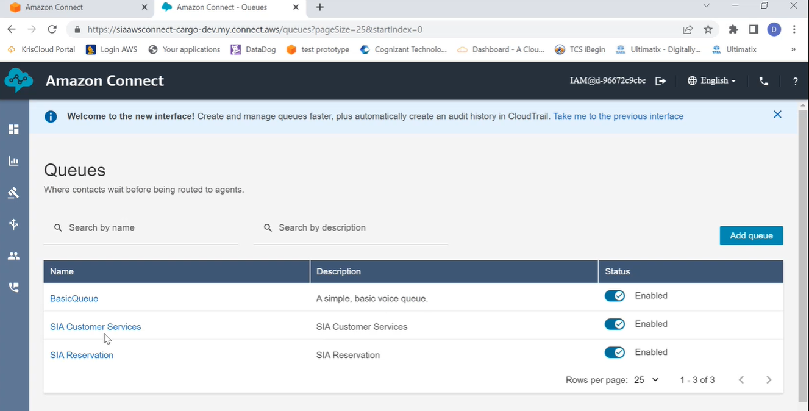

Under the contact flows interface, all the required contact flows are created as below.

